**MAC _OS ASSIGNMENT**

**Member 1:** Muhammad Fahad **Member 2:** Jaffar Abbas

(FA19-BSSE-0014) (FA19-BSSE-0008)

**Member 3:** Samin Tariq **Member 4:** Ahmed Amin

(FA19-BSSE-0010) (FA19-BSSE-0063)

**Course:** Operating System Lab

**Section:** BM

**Teacher:** Miss Sumra Khan

* 1. **Create directories A and B.**

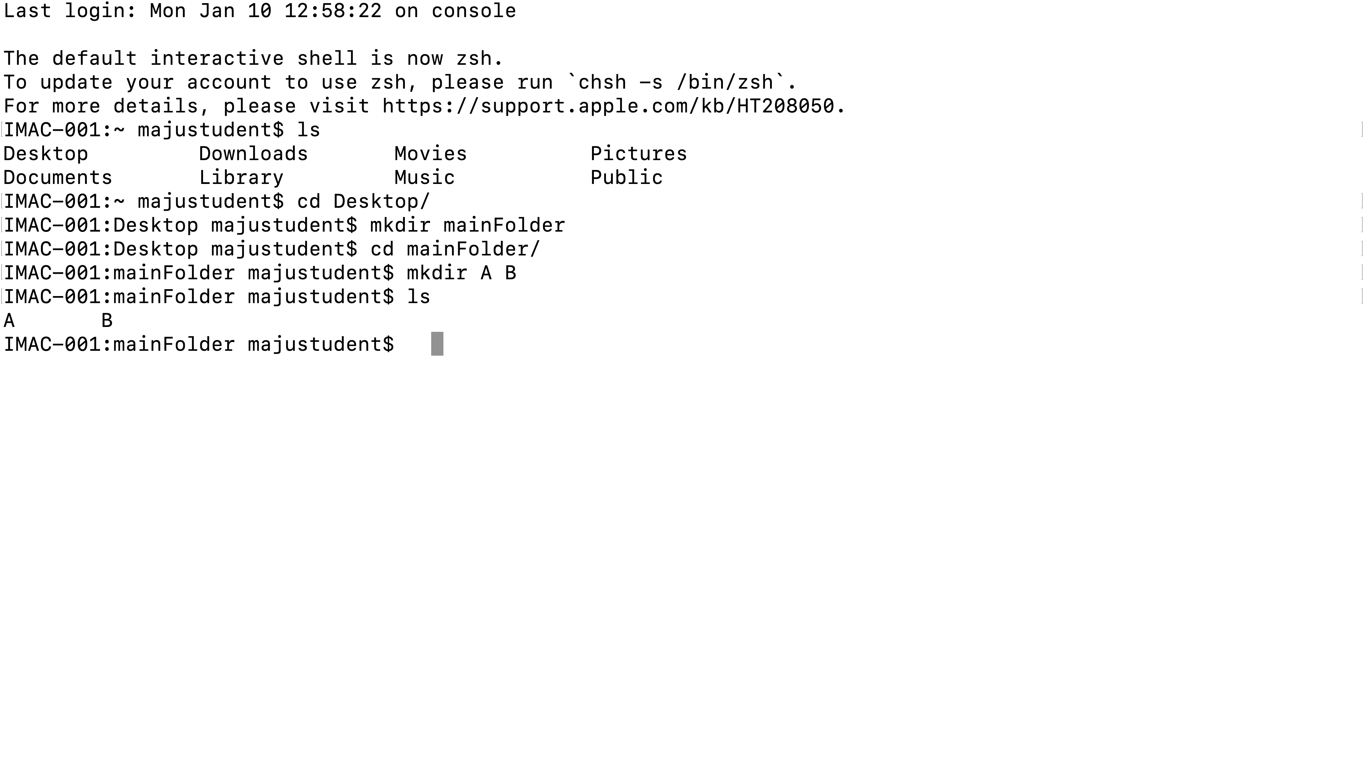

* 1. **Create a file in directory A named Textile using cat command.**

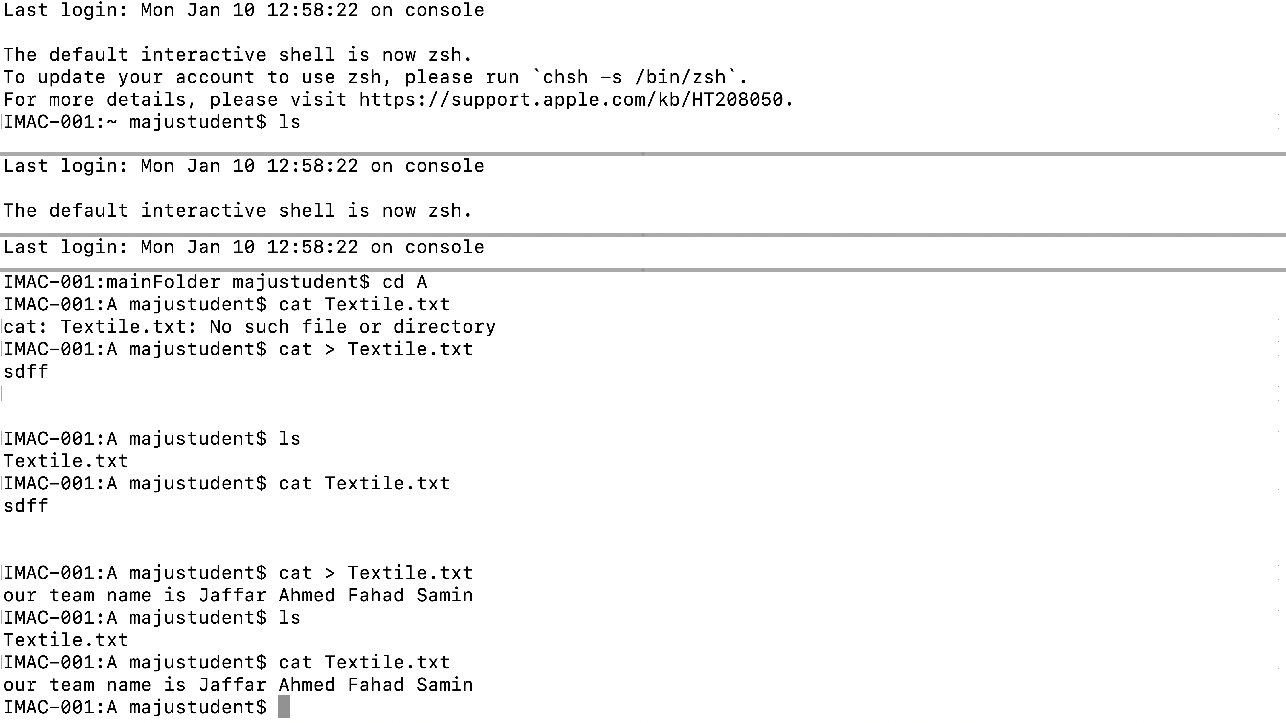

* 1. **Write YOUR PERSONAL INFORMATION in to file.**

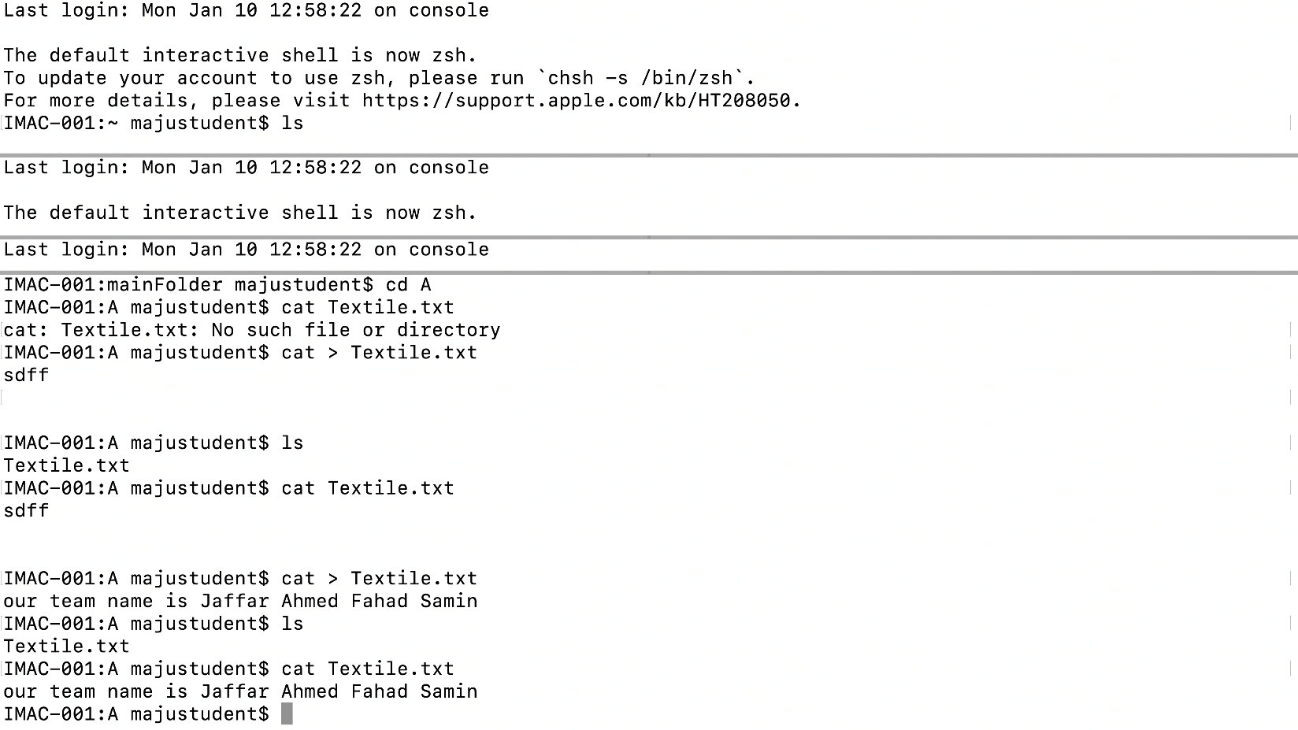

* 1. **Create text files named file1, file2 and file3 in directory B using touch command.**
  2. **Merge files file1, file2 and save it in file3.**
  3. **Create a file and set permissions to the created file of your own choice (using both symbolic and absolute mode)**
  4. **Change ownership and group of a file.**
  5. **Write a shell script to take a number input from user and then print the table for the given number.**

**I.e. if n=5 then 5*1=5.**

* 1. **Which pipe of commands would you use to count the number of processes owned by you only? Run the command and count how many processes you own?**